
Plain English 2025
Maydot Supports
Participant Handbook

Table of Contents
About this handbook 3
About Us 5
Our Services 6
Service Access 7
Service Agreement 8
Your rights 9
Your responsibilities 10
Your values and beliefs 11
Privacy and Dignity 12
Information and Consent 13
Your services 15
Support Planning 16
Advocacy 17
Safety 18
Incidents 19
Feedback and complaints 20
Continuous improvement 21
Ending your services 22
NDIS Commission 23
The Office of the Australian Information Commissioner 24
Contacting us 25

About this handbook
This handbook provides you with important information about using our services, as well as your rights and responsibilities as a NDIS participant.

About Us

Maydot Supports is a local support provider. We provide supports in the Albury Wodonga region and surrounding areas up to 100km’s away.

Our Vision
Our vision is for disadvantaged, vulnerable or young people who have a disability to receive person centred support that helps them live their best life and be an active part of their community.

Our Mission
Our mission is to enhance the support service experience for our local community.

Our Values

- Inclusion – We will always support people to make their own choices about how they live and take part in their community.
- Integrity – We will always aim to do the right thing and work in line with our values.
- Honesty – We will be honest and open, even when we make mistakes.
- Kindness – We will aim to treat you with consideration, helpfulness and kindness.

Our Services

We deliver the following services to NDIS participants:

Core Supports:
- Assistance with daily personal activities (self-care and personal domestic included)
- Assistance with Household tasks (prep and delivery of meals included)
- Transport
- Assistance with social, economic and community participation (community access included)
- Respite
Capacity Building supports:
- Assistance with accommodation and tenancy obligations
- Community Participation activities
- Development of daily living and life skills
- Community Engagement assistance

Maydot Support’s also offers services to individuals who are privately funded or alternatively funded through another government body or agency.
If you are supported through another government body or agency and are interested in our services, please contact us to enquire.

Please contact us if you have any questions about our services or if you would like to know more about how we can help you.

We can help you if you need communication support by:
- using an interpreter; or
- giving you information in a format appropriate to your communication needs.

Service Access

You have the right to access services that help you to reach your goals.

Please contact us if you want to receive our services. We will ask you some questions about yourself, your lifestyle and what you want to achieve with us.

We will tell you about our services and any fees you will need to pay.

To receive our services, funded through the NDIS, you must have an NDIS plan which includes the type of supports which we provide.

Your choices are always important to us. With us, you will have choice and control over the services.

If we cannot deliver services to you, we will inform you of the reason why. We will let you know under what circumstances supports may be withdrawn. We will also link you to other services that are similar.

If we are unable to deliver services to you because we are too busy, we can put you on a waiting list. If you are on the waiting list, we will contact you to:

- tell you how long you need to keep waiting;
- tell you where you are on the list; and
- ask if you want to keep waiting.

If you do not think we have been fair during this time, you can make a complaint to us. To learn how to do this, look at the section about Feedback and Complaints in this handbook.

Service Agreement

If you want to receive our services, we will work with you to make a service agreement.

We will involve the people you wish, such as a carer, support person or advocate, family or friends.

We will make sure you understand what is in your service agreement, which may include:
- the services we will deliver
- how we will meet your goals
- how and when we will review the agreement
- any fees
- how you will pay fees
- your rights and responsibilities
- our responsibilities
- any conditions
- what to do if there is a problem
- how to cancel an appointment
- how you can change or end the agreement and/or
- how we can change or end the agreement
- What happens if there is an emergency or disaster.

We will ask you to sign the agreement, once we have finished the service agreement, we will give you a copy in a format that you understand.

Your rights

We will respect and support your legal and human rights, including your right to:
- be treated equally
- plan and make decisions about your services and your life
- get help or information to help you decide
- involve an advocate, carer or friends and family close to you
- have an advocate or support person represent you
- choose how you spend your money and funding
- receive services that help you reach your goals
- practice your culture and religion
- choose the people or community you spend your time with
- use an interpreter
- receive information in a different format and
- give feedback about our services.

You also have the right to:
- privacy and dignity
- intimacy
- safety and
- respect.

Your responsibilities

You also have responsibilities when you receive our services. It is your responsibility to:

- respect our workers and other participants
- be polite to others
- act safely at all times
- tell us about the services you want and how you want to receive them
- tell us as soon as possible if you need to cancel an appointment
- tell us of any changes in your life that may affect our services and
- pay for our services on time.

Please contact us if you are unhappy with our services or if there is a problem.

You must also tell us if:

- you want to stop receiving our services
- your NDIS plan changes or
- you stop using the NDIS.

Your values and beliefs

Our goal is to support you to live your life the way you wish.

These may include your:

- culture and values
- beliefs and religion
- identity and sexuality
- family and community
- language
- goals
- strengths
- abilities.

Our services can help you to spend time with the people or community important to you and support your independence.

We value the diversity in our community, so we can speak or write to you through an interpreter or in other formats if needed.

Privacy and Dignity

Everyone has the right to privacy, dignity and intimacy.

We make sure information about you is kept private and confidential.

You do not need to give us your personal information. However, if you do not, we may not be able to deliver services to you.

Information and Consent

We ask for your consent to collect personal and sensitive information about you.

Personal and sensitive information can be:
- your name
- your contact details
- your health
- your religion, nationality or culture or
- photographs or videos of you



We collect this information from you, or people and providers you consent to, so that we can deliver services to you.

We also use it to improve our services and to follow the law.

We may take photos or videos of you, but we will only do this if you have given consent.

We will always tell you what the photos or videos will be used for. If you change your mind at any time about what you have consented to, please tell us and we will update our records.

We have ways to protect your information by keeping it in a safe place like on a computer or in a file and protecting it with passwords and locks.

We only give your information to workers who are involved in your services and people or providers you consent to. However, sometimes by law we must share your information without your consent. This can be to keep you or others safe. If we lose your information or if someone steals it, we will inform you in line with the Notifiable Data Breaches Scheme.

You also have the right to look at and get a copy of the information we keep about you. If you think any of the information about you is wrong, you can let us know.

We will either correct it or add your comments. If you are unhappy about how we have kept your information you can complain to us. To learn how to do this, look at the section about complaints in this handbook.

We will keep your information for the necessary amount of time in line with the law. After that, we will destroy it safely. Please tell one of our workers if you want a copy of our privacy procedures.

Your services

We will work with you to plan and choose your services.

We can help you to get information, help or advice to make decisions about any part of your services, any time.

If you make any decisions that we consider to be a risk, we will help you understand what might happen if you take that risk.

Your services will be person-centred and will not restrict your rights.

If we ever need to make changes to your services, we will inform you. We will explain the changes and ask for your agreement.



Support Planning

You will be involved in planning your services. If you wish, you can also involve a carer, friends, family or an advocate.

In order to create a support plan together, we will ask you to tell us about your strengths, needs, preferences and goals.

With your consent, other providers may also be involved.

We will consider any risks in delivering your services and try and keep you and others safe by reducing these risks.

We will talk with you about your support plan and risks every year. However, we may do it sooner if your needs or situation changes. We will look at your goals and what you have achieved often, to make sure our services are successful.

You can tell us at any time if you think our services are not helping you to reach your goals or meet your needs, and we will help you to change your plan.

With your consent, we will share information about your services and support plan to relevant people, providers and agencies.

Advocacy

You have the right to have an independent advocate.

An advocate is someone who protects your rights, help us to understand your needs and goals, and can help you to make decisions.

If you wish to have an advocate represent or support you, please let us know.

Your advocate can attend service planning meetings and can also speak for you, if you wish.

You may want to use an advocate if an incident occurs, or if you make a complaint.

We can help you to find an advocate if you ask us. A list of disability advocacy agencies is available at this link: https://askizzy.org.au/disability-advocacy-finder

Safety

You have the right to be safe, respected, free from abuse or neglect and treated equally.

Our workers are trained to understand your rights and recognise signs when you may not be safe, so that they can deliver safe services.

We will always treat reports of violence, abuse, neglect, exploitation and discrimination seriously and encourage you to tell us if this happens to you.

We will make sure the support environment is safe for you and other participants.

If you receive services in your home, we will work with you to consider and control risks.

With your consent, we may also work with other providers who support you to do this. Where it is possible, we will make changes to your support environment so that it is safe, suitable for you and meets your needs.

Incidents

If an incident takes place when you are receiving services, our workers will act in line with procedures. They will do their best to make sure you are safe.

After an incident, we will investigate what happened and keep you informed of we are fixing it. Where it is appropriate, we will involve you.

We will offer you help and support, including helping you to contact an advocate.

We may ask for your opinion about the incident. This information will help us improve our services and stop incidents like this from happening in the future.

If the incident is very serious, we may need to report the incident to the NDIS Commission in order to follow by the law. If you want a copy of our incident procedures, please let us know.

Feedback and complaints

You have the right to give feedback about any part of our services. Or, if you are unhappy with our services you can make a complaint. You can give feedback or make a complaint in the way you feel most comfortable.
You can:

- fill in a feedback form
- tell a worker or
- ask an advocate or support person to make a complaint for you.

If you make a complaint, we will treat it with respect and privacy. Your services will not be stopped, and you will not be treated differently.

We will contact you within 2 business days to confirm that we have received your complaint. We may ask you for more information and ask how you would like it to be fixed. We will keep you informed of the progress of your complaint and tell you what we did to fix it. We will ask you for feedback about how you felt your complaint was managed and use this information to help us improve our services.

You also have the right to complain to the NDIS Commission about our services at any time. We can help you contact the NDIS Commission if you wish. The contact details of the NDIS Commission are at the end of this handbook.

Complaints can also be made anonymously
If you are unhappy about how we have kept your information, you can also complain to the Office of the Australian Information Commissioner. The contact details of the Office of the Australian Information Commissioner are at the end of this handbook.

Please contact us if you want to see our feedback and complaint procedures.

Continuous improvement

You have the right to give us feedback – positive and negative. We will use any negative feedback to improve our services. Positive feedback lets us know what we are doing well.

We will ask you to tell us your thoughts about our services. We may do this by giving you a feedback and complaints form. Or we may ask you to go to participant meetings to talk about what you think we can do better.

Sometimes we will ask for your thoughts on a particular part of our services. For example:
- how we fix complaints
- how we fix incidents or
- how we respect your rights.

Our service will be audited by an independent audit team to ensure we are meeting the NDIS Practice Standards. You will be automatically ‘opted in’ to the audit process if you have already consented, meaning that you may be asked for your feedback by the audit team. However, this is not mandatory, and you can ‘opt out’ at any time.

We aim to improve continuously. The following are some of the things we look at to guide how we improve:

- feedback
- complaints
- incidents and
- audits.

Ending your services

You can end our services at any time. However, you must tell us 7 days before you want to end your services. You will have the same rights if you want to receive our services in the future.

If you end our services, we will help you plan other services to meet your needs or give you information about other providers.

If you give consent, we may give other providers information about your needs. We will also consider your risks and try to reduce them and put this information in an exit plan.

We will do this to try to make sure you are safe, and your needs are met while your services change.

If we want to stop delivering our services to you, we must give you a reason why and tell you 7 days before.

We may stop delivering services to you if we think we cannot help you, you do not pay for the services we deliver, or you break our agreement. However, we cannot end your services because you have made a decision about risks that we do not agree with.

NDIS Commission

The role of the NDIS Commission is to improve the quality and safety of NDIS supports and services.

You can call the NDIS Commission on 1800 03 55 44. Or you can write to them at:
Website: www.ndiscommission.gov.au
Email: contactcentre@ndiscommission.gov.au
Address: NDIS Quality and Safeguards Commission
PO Box 210
Penrith NSW 2750

Further details about contacting the NDIS Commission are available at: https://www.ndiscommission.gov.au/about/contact

The Office of the Australian Information Commissioner

The role of the Office of the Australian Information Commissioner (OAIC) is to ensure that personal information is protected. The OAIC will investigate complaints about breaches of privacy.

You can call the Office of the Australian Information Commission on 1300 363 992. Or you can write to them at:

Website: www.oaic.gov.au
Email: enquiries@oaic.gov.au
Address: Office of the Australian Information Commissioner
GPO Box 5218
Sydney NSW 2001

Contacting us

Our business hours are 9am – 5pm. During business hours you can call us on 0497833760 or visit us at www.maydotsupport.com.au

You can write to us at 51 Michelle Ave, Lavington NSW 2641

You can email us at maydot2024@outlook.com.

Or, you can contact us through our website www.maydotsupport.com.au.

If you need communication support, you can call the National Relay Service (NRS) on 133 677 or www.relayservice.gov.au or call the Translating and Interpreting Service (TIS) on 131 450.

My name is: ________________________________

This Participant Handbook was provided and explained to me on:

01/01/2025

Signed: ____________________________________
Or advocate (if applicable)

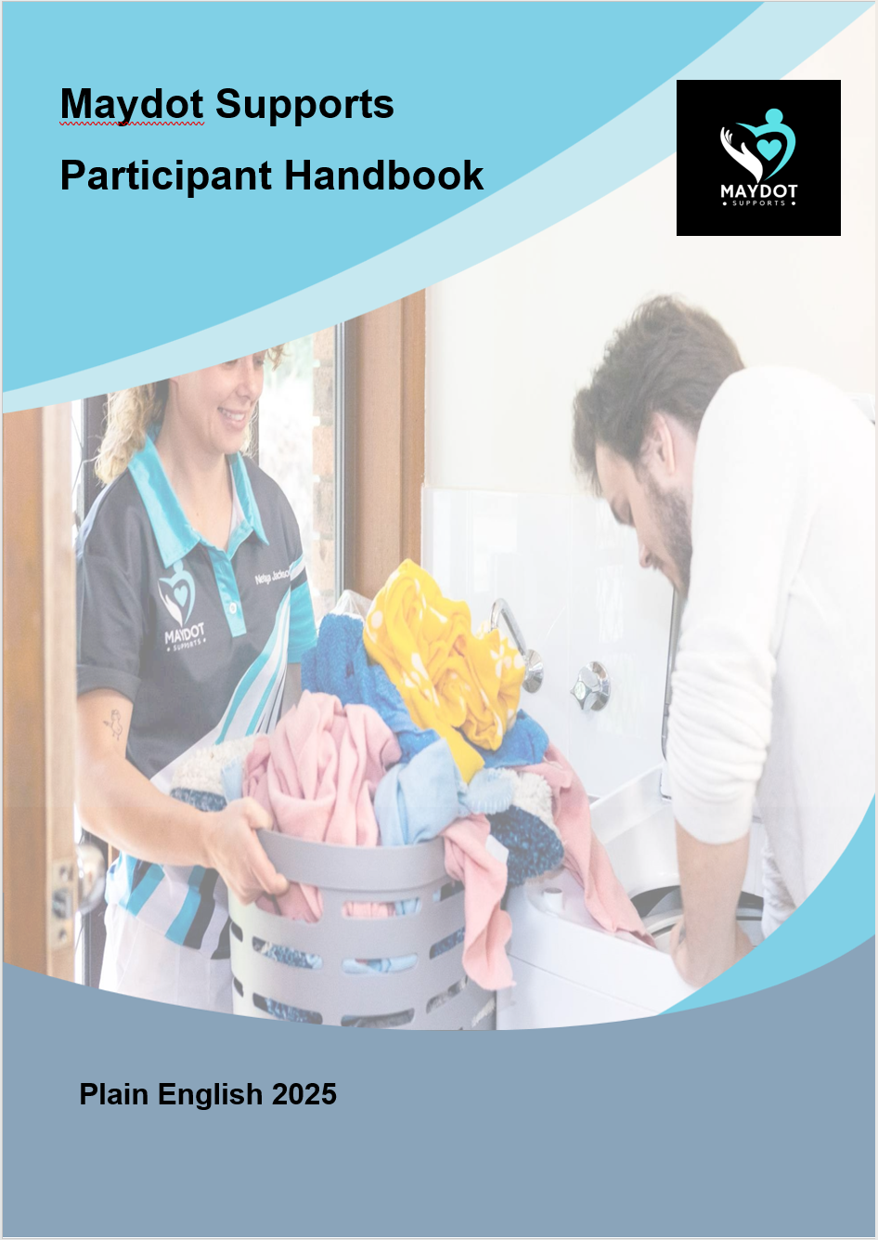

This page should be retained on participant file




0497 833 760

www.maydotsupport.com.au

maydot2024@outlook.com

Maydot Supports
© This document was developed by Engels Floyd & Associates www.engelsfloyd.com

